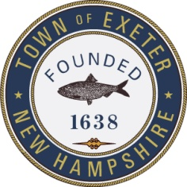
TOWN OF EXETER, NEW HAMPSHIRE
10 FRONT STREET • EXETER, NH • 03833-3792 • (603) 773-6110
www.exeternh.gov

Unified Elderly Tax Exemption Guidelines (RSA 72:39a)

2026 Age and Residency Requirements
You must be age 65 or over as of April 1 of the year you are applying and a resident of New Hampshire for the past 3 or more years. The property on which the exemption is claimed must be your principal place of abode.
Age before April 1st 65-74 $ 198,000 off assessed value
Age before April 1st 75-79 $ 238,000 off assessed value
Age before April 1st 80-up $ 307,000 off assessed value

Income (including Social Security)
Single less than $43,000
Married less than $55,000
Income limitations specified are based upon earnings during the prior calendar year. Examples of income are included but limited to: wages, self-employment earnings, pensions, annuities, rentals, interest, and social security benefits.

Assets
Total assets may not exceed $194,251 whether married or single.
The residence on which the exemption is claimed is excluded from the above limitation; all other property is an asset whether located in State or out. Examples of assets include but are limited to: savings and checking accounts, stocks and bonds, CD’s and money market accounts, vehicles, household goods, antiques, jewelry and furs. Anything which can be sold for cash is an asset.
Multifamily homes: The unit(s) you do not reside in must be included as an asset.

Filing Deadline
The filing deadline is April 15th preceding the setting of the tax rate. Example: If you are applying for an exemption off your 2026 property taxes, you have until April 15, 2026, to file this form.

In order to process your exemption we will need copies of the following:
Social Security Statements ALL Income Statements
IRS 1040 completed form ALL Asset Statements
1099 forms (interest from the Banks)
Pension Statement
Checking and Savings Statements
If you have any questions, please call the Assessor’s Office at 773-6110

